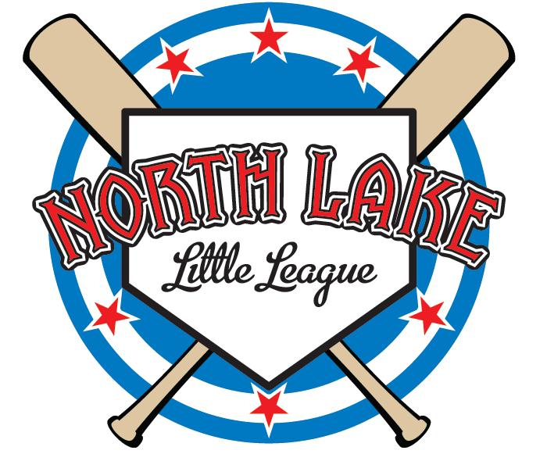
North Lake Little League Medical Release Form

In case of an emergency, I hereby authorize my child to be treated by Certified Emergency Personnel. (i.e. EMT, First Responder, E.R., Physician)

Player:______________________________________________DOB:___________________

Family Physician:___________________________________Phone:____________________

Hospital Preference:___________________________________________________________

Emergency Contact:________________________________ Phone: ____________________

Allergies:____________________________________________________________________

Parent/Guardian Authorization:__________________________Mobile:___________________

Player:______________________________________________DOB:___________________

Family Physician:___________________________________Phone:____________________

Hospital Preference:___________________________________________________________

Emergency Contact:________________________________ Phone: ____________________

Allergies:____________________________________________________________________

Parent/Guardian Authorization:__________________________Mobile:___________________

Player:______________________________________________DOB:___________________

Family Physician:___________________________________Phone:____________________

Hospital Preference:___________________________________________________________

Emergency Contact:________________________________ Phone: ____________________

Allergies:____________________________________________________________________

Parent/Guardian Authorization:__________________________Mobile:___________________
WARNING: Protective equipment cannot prevent all injuries a player might receive while participating in baseball.
Copy page and fill out for every player. Must be with manager at all games & practices.

